**Canada Vigilance Application**

**User Manual**

**Revision Sheet**

|  |  |  |  |
| --- | --- | --- | --- |
| **Revision No.** | **Description of Revision** | **Author** | **Date** |
| 1.0 | Initial draft | Ashraf Sirag | 2017-07-21 |
|  |  |  |  |
|  |  |  |  |
|  |  |  |  |
|  |  |  |  |
|  |  |  |  |
|  |  |  |  |

**TABLE OF CONTENTS**

Page #

1.0 GENERAL INFORMATION 1

1.1 Canada Vigilance Adverse Reaction Database and Caveat 1

1.2 The CV App Overview and Maintenance 1

2.0 SYSTEM SUMMARY 3

2.1 System Configuration 3

2.1 Logging On 3

3.0 GETTING STARTED 4

3.1 System Menu 4

3.1.1 Search Tools 4

3.1.2 Result Tabs 5

3.2 Results display 5

3.2.1 Drug Adverse Event Reports Graph 6

3.2.2 Result Tabs Display 7

3.3.2.1 Reports 7

3.2.2.2 Patients 8

3.2.2.3 Drugs 9

3.2.2.4 Reactions 10

3.2.2.5 About 10

3.2.2.6 Download 10

4.0 USING THE CV APP 12

4.1 Drug Search 12

4.1.1 Drug Name Type 12

4.1.2 Drug Involvement 12

4.1.3 Seriousness 12

4.2 Adverse Reaction Search 13

4.2.1 Preferred Term (PT) 13

4.2.2 System organ Class (SOC) 13

4.3 Other Search Options 13

5.0 SEARCH EXAMPLE 14

5.1 Search Tools 14

5.2 Results display 16

# 1.0 GENERAL INFORMATION

## 1.1 Canada Vigilance Adverse Reaction Database and Caveat

The Canadian Vigilance Adverse Reaction Database stores information on suspected adverse reaction reports pertaining to marketed health products[1]. These reports are submitted to Health Canada by health care professionals and consumers who initiate submissions voluntarily, and by Market Authorization Holders (MAH) who are required to submit reports. It is important to note the data is collected through a spontaneous surveillance system and is subject to under reporting of adverse reactions in both the voluntary and mandatory surveillance systems. As a result, the information extracted from the reports in the database should not be used as a means for determining the incidence of an adverse reaction or usage of a health product within the population. Although heath products and adverse reaction pairs may form a temporal relationship, a casual association cannot be inferred; meaning the user cannot conclude that a health product caused a specific adverse reaction based only on the reports in the database. The purpose of the Canada Vigilance Adverse Reaction Database is to detect potential signals of adverse reaction and health product associations so that they may be scientifically analyzed and validated by the Canada Vigilance Program.

## 1.2 The CV App Overview and Maintenance

The Canada Vigilance application (CV App) developed by the Research Management and Operations Directorate (RMOD) within Health Canada, was created to allow users to access the reports in the Canada Vigilance Adverse Reaction Database (figure 1). Through an interactive dashboard, the CV App allows users to effortlessly analyze thousands of reports and view results of specified searches. The CV App uses search tools to filter the reports contained in the Canada Vigilance Adverse Reaction Database and displays graphs, charts, and tables based on the user’s request. The adverse events are coded according to the Medical Dictionary for Regulatory Activities (MedDRA) version 19.1; while the drug names are coded according to those used in the Canada Vigilance Adverse Reaction Database. Up to date reports is the responsibility of the Canada Vigilance program, but the manual updating and maintenance of the application is still unclear.

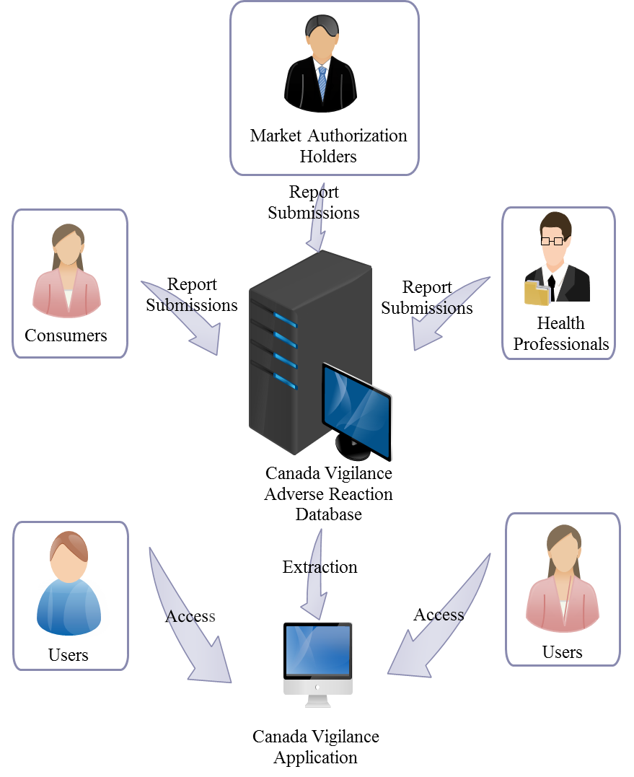

Figure 1. Data flow from submitted reports to the user

# 2.0 SYSTEM SUMMARY

## 2.1 System Configuration

The Canada Vigilance Application (CV App) is a web based application that uses the same URL while the user navigates different options and searches. This means that any searches performed are not saved in the user’s browser history, nor can they be returned to by pressing back or forward button on the browser. The only way to return to a once completed search is to reinput the same search specifications used at the time.

## 2.1 Logging On

As stated before, the CV App is a web based application that does not require any installation of software or an account registration/login, but does require functioning internet access and can be accessed through the URL: <https://shiny.hres.ca/CVShiny/> on any major internet browser.

# GETTING STARTED

## 3.1 System Menu

The CV App menu can be divided into two sections: the search tools (Figure 2) and results tabs (figure 3).

### 3.1.1 Search Tools

Figure 2 displays the default search options when the user first opens the web application and is located to the left hand side. The search tools use a variety of methods for allowing users to select what they want to include/exclude in/from their reports search. There are three search bars located on the left hand side of the application which are the: Drug name, Preferred Term (PT), and System Organ Class (SOC) that require the user to manually type the search term they are attempting to use. Another type of search tool at the bottom left hand side of the application involves choosing a single option from a list and is used for filtering the year and month reports were received by Health Canada and the gender of the patient in the report. The last few search tools simply involve clicking a set of options, as seen in the: Drug name type, Drug involvement, and Seriousness options, and as well and dragging (for the patient age range) the desired option.

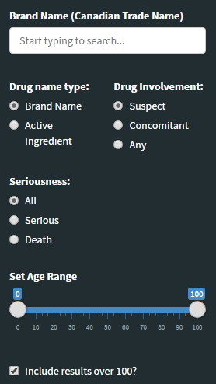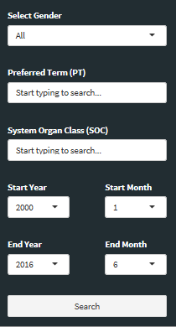

Figure 2. Search Tools

### 3.1.2 Result Tabs

Once the user has filled out and selected all the search specifications, the user then has the option to choose what results are displayed using the result tabs located above the drug name search bar on the left hand side (figure 3). The first tab labelled Reports displays information on the reporter type, seriousness, and reasons for seriousness, The Patients tab gives information on the patient’s gender and age. The Drugs tab mainly displays the most frequently reported drugs in the reports for suspect drugs, concomitant drugs, and both. As well, the Drugs tab displays the reports per indication and the number of drugs per report. The last tab within the results menu labelled Reactions displays the most frequent adverse events both in preferred terms and high-level terms, and also displays the report outcome.

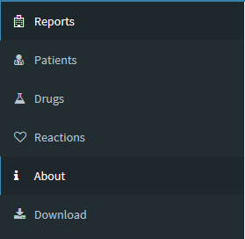Figure 3. Result Tabs

## 3.2 Results display

To the right of the search tools are the results which display various charts/tables depending on what has been entered in the search specifications. The results display consists of a bar graph describing the total reports that have been filtered located towards the top of the application titled Drug Adverse Event Reports Graph displayed in figure 5. Below this graph are results displayed based on what is selected in the results tabs in the form of various tables/graphs. Most bar/pie charts displayed also give the option to be viewed in table form as displayed in figure 4. In addition, figure 4 also outlines the “i” icon which is a pop-up information box that gives an explanation of the chart’s content when the cursor is placed over it, and can be found in all titles in the results display aside from the Drug Adverse Event Reports Graph.

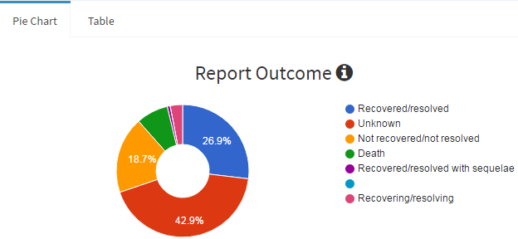Figure 4. Report Outcome Pie Chart

### 3.2.1 Drug Adverse Event Reports Graph

The graph located towards the top of the application gives a clear display of the total reports pertaining to the drug adverse event reports based on the selection the user has made. If the user inputs a drug name and/or a preferred term, then this will be reflected in the graph’s title and the filtered reports. If the user adds no search specifications then the graph will simply display all the reports in the Canada Vigilance Adverse Reaction Online Database from the year 2001 (the default setting) as shown in figure 5.

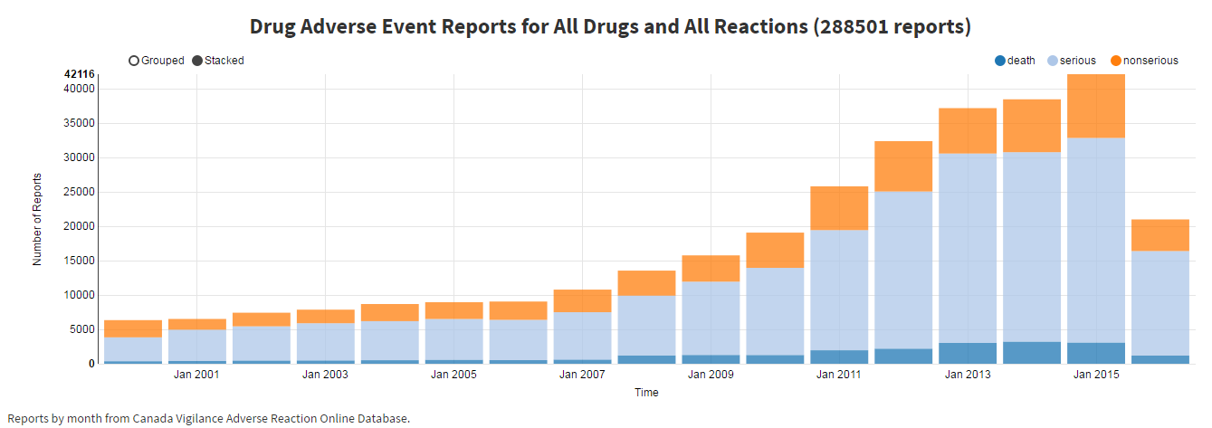

Figure 5. Drug Adverse Event Reports for All Drugs and All Reactions in Stacked form

Unlike the display results below, the drug adverse event reports graph has no toggle options and is fixed to the top of the web application. The graph itself, displays the number of reports submitted as a function of time (years or months depending on the length of time between the oldest and most recent report). Each increment of time displays three bar graphs pertaining to the total serious, death, and non-serious events listed in the filtered reports. It is important to note that the serious report totals for each increment of time, includes the total reported death due to death being considered a serious reaction. The total amount of filtered reports within the user’s specified time frame can be found in brackets beside the title. The drug adverse events reports graph also has the option to view the bars/columns in either grouped or stacked form and is circled in figure 5.

### 3.2.2 Result Tabs Display

As mentioned in the previous section 3.1.2, the results tabs allows the user to only show charts and tables on the specific results they desire based on the filtered reports. While the drug adverse event reports graph stays fixed to the top of the application, the results tabs display can be toggled to show a multitude of results. As well, placing the cursor on any category in a chart will display its numerical value and percentage of the whole (if it’s a pie chart). The results tab contains five categories: Reports, Patients, Drugs, Reactions, and Download (exporting), but has a sixth tab labelled “About” that gives extra information on the Canada Vigilance web application.

#### 3.3.2.1 Reports

The first graph in the reports tab displays the reporter type which gives the total amount of reports initiated by each reporter title and an example can be seen in figure 6 (in table form).

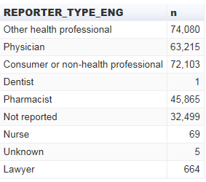

Figure 6. Reporter Type in the form of a table using the default search settings

In addition, the percentage/total counts of serious to non-serious reports of adverse reaction are also displayed (figure 7).

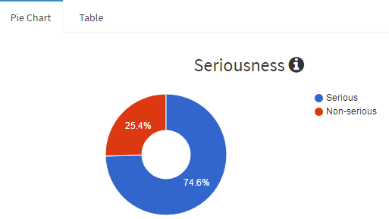

Figure 7. Seriousness Pie Chart

The last chart is a non-interchangeable graph that displays the reasons for seriousness and the number of reports that fall into each category.

#### 3.2.2.2 Patients

Selecting the Patients tab displays two tables/charts pertaining to the gender and age group of the individuals included in the report who experienced an adverse reaction. The specific ages within the age groups can be found in the mouse-over information box beside the title age group as seen in figure 8. The patient tab also includes a histogram displaying a distribution of ages within the reports and gives an enhanced visualization of the patient ages.

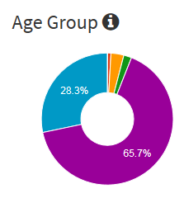

Figure 8. Age Group pie chart, with the title and mouse-over information box circled

#### 3.2.2.3 Drugs

Similarly, the drugs tab offers the choice of a horizontal bar graph or table for the first four drug results charts and a single vertical bar graph for the last. This tab commonly refers to drugs as either suspect or concomitant. **Suspect** drugs are drugs included in an adverse reaction report that is suspected of causing the observed adverse effect[2]. While a **concomitant** drug is one taken at the same time an adverse reaction was experienced but is not suspected in causing the adverse reaction2. The first three graphs all display the most frequently reported drugs but differ in the types of drugs they display (figure 9). Graph one displays all the most frequently reported drugs in all the filtered reports regardless of whether they are categorized as concomitant or suspect drugs. The second graph displays the same results but only for suspect drugs; while graph three displays results for only concomitant drugs. Graph four displays the reports per indication which are the health issues/diseases that all the drugs in the included reports were taken for. The very last graph in the drugs tab is a vertical bar graph and indicates the amount of reports that contain one or more drugs.

22

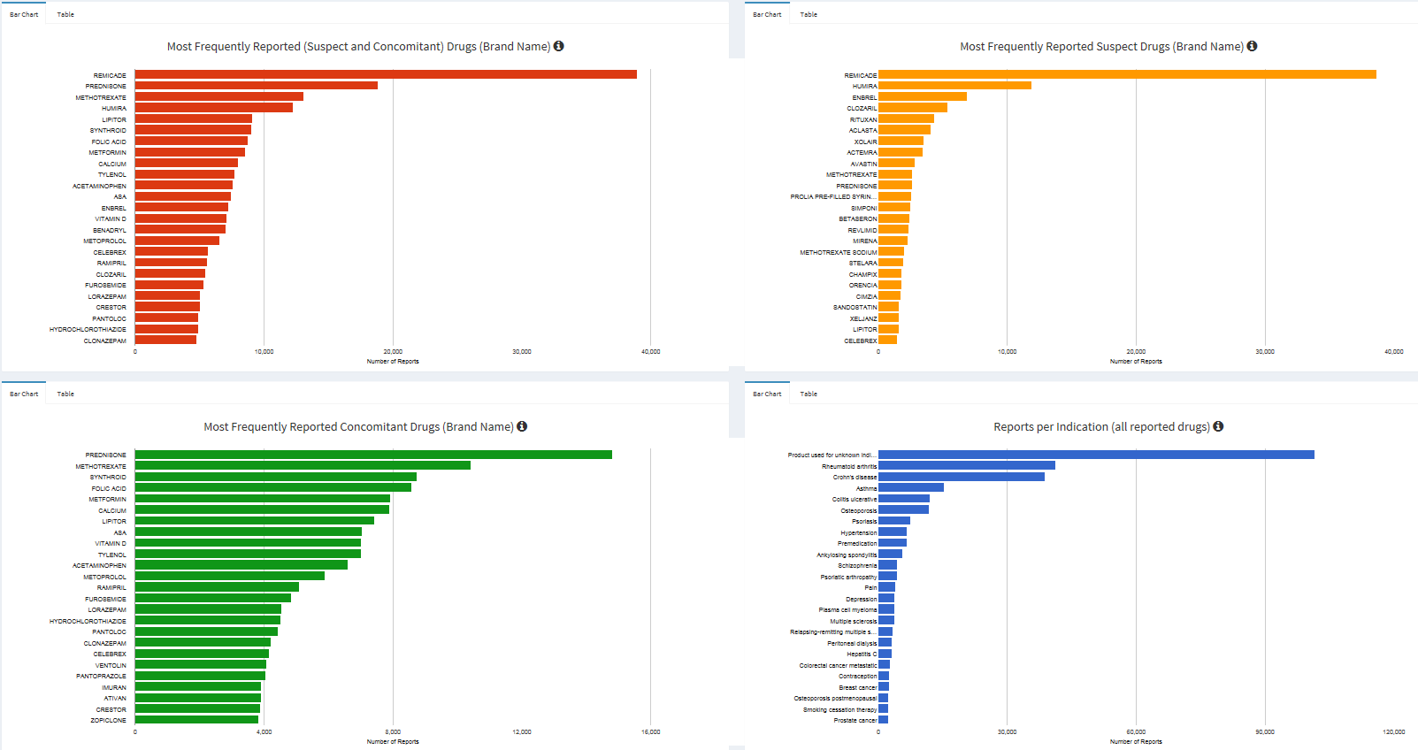

1

4

3

Figure 9. 4/5 graphs displayed in the drugs results tab using the default search input.

#### 

#### 3.2.2.4 Reactions

The first two graphs in the Reactions tab display the most frequently reported adverse reactions indicated in the reports the user has filtered in preferred terms (PT) in the first graph and high-level terms (HLT) in the second graph. PT and HLT correspond with MedDRA’s hierarchical classification of adverse reactions. A **PT** is a specific descriptor for a sign, symptom, or disease diagnosis[3] and is the second lowest term in MedDRA’s hierarchy[4]; while **HLT** is one category higher that a PT and gives a more general category of adverse reactions than a PT. Each HLT includes one or more PTs, but only one PT belongs to a single HLT, for example the PT nausea and the PT vomiting both belong to the HLT nausea and vomiting symptoms. The last graph is a pie chart that displays the report outcome, which is the status of the person after the adverse reaction was experienced and can range from recovery to death.

#### 3.2.2.5 About

The About tab gives the user a very brief summary as to who the CV App developers are, as well as a few links to the Canada Vigilance Adverse Reaction caveat document and database. This tab also highlights some key information such as the date the data was last updated and the current MedDRA version the application is using.

#### 3.2.2.6 Download

The CV App also allows users to download the results of their searches in the form of an excel file so that further analysis can be performed. The option bar titled “Download Type” gives the user three options pertaining to the data from the filtered reports that can be extracted (report data, drug data, and reaction data). Each download type entails a set of categories of information (i.e report id or gender) which can be further customized in the box titled Select Columns to include or exclude certain categories from their soon to be exported excel file by simply clicking on the box below and selecting or deleting columns from the options that pop-up. The information to the right of the two aforementioned boxes displays the user’s search specifications such as seriousness, name type, or age range etc. The titles “Name” and “Name Type” both refer to the drug name and drug name type. Unfortunately, columns from different download types cannot be combined into a single download and must be downloaded in separate excel files.

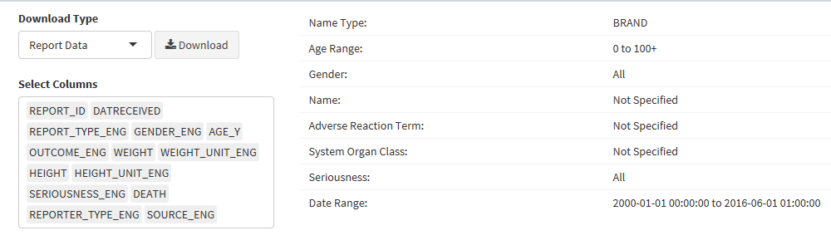Figure 10. The Download tab display.

# 4.0 USING THE CV APP

## 4.1 Drug Search

The drug search utilizes one of the three search bars on the left hand side of the application. Here the user can filter reports based on a specific drug name type by either its brand name or active ingredient. The user can also specify this drug’s involvement by choosing the option that filters reports based on whether the searched drug is suspect, concomitant, or any. As well, the user is given the choice to filter the seriousness of adverse reactions. If the user chooses to search for a drug name then one of the options from drug name type and drug involvement must be selected or the default options already selected will be used to filter reports (brand name and suspect respectively). When the user begins to type their drug name search, a list of suggestions will begin to pop-up below. The CV App only recognizes preset terms, meaning the user can type the term they want but ultimately have to choose a term based on what is suggested. It is possible to select multiple drugs in a single search, although this will not only filter reports that contain all of the searched drugs, but rather filter reports where any of the searched drugs are reported.

### 4.1.1 Drug Name Type

As mentioned before, the CV App uses two possible options for choosing the drug name when using the drug search bar that will change the suggested drug names. The first option under the drug name type is **brand name** which can be defined as the name the manufacturer assigned to the product, as well a drug’s brand name can be indicated on its packaging or label[5]. The second, and only other option, is the **active ingredient** which is any component that has medical properties, and plays a role in pharmacological activity or directly affects the diagnosis, cure, mitigation, treatment or prevention of disease, or affect the structure or function of the body of man or other animals3. As well, drugs can contain multiple active ingredients, and the same active ingredient can me sold or advertised under different brand names.

### 4.1.2 Drug Involvement

The CV App also allows the user to filter reports based on a drug’s involvement in an experienced adverse reaction. Selecting the suspect or concomitant options will filter reports on the drug the user has searched based on whether it is suspected of causing the adverse health effect or was simply taken at the time the adverse health effect was experienced, respectively. For a complete definition of suspect or concomitant drugs please refer to section 3.3.2.3.

### 4.1.3 Seriousness

The last option in the drug search allows the user to filter the reports based on the seriousness of the adverse reaction, which is determined by the reporter at the time of reporting. Health Canada defines a **serious reaction** as a noxious and unintended response to a drug that induces or prolongs hospitalization, causes malformation, is life-threating or results in death, or results in persistent or significant disability[6]. The three options given allow the user to filter either serious reports, only death reports, or include all (both).

## 4.2 Adverse Reaction Search

When searching for an adverse reaction, the user is given a choice between using the PT or the system organ class (SOC) term. Both terms assist in specifying an adverse reaction, but the PT identifies specific adverse reactions while the SOC term identifies much more general categories of adverse reactions. Similar to the drug search bar, both the PT and SOC search bars allow multiple search terms (adverse reactions or organ classes) to be selected simultaneously and filters reports that contain any of the terms selected, as opposed to only filtering reports containing all terms. Although this is only true for searches within the PT or SOC search bars. Entering terms in both the PT and the SOC search bars simultaneously is redundant because the application will only filter reports if the preferred term is within the System organ class category (i.e. nausea and gastrointestinal disorders, respectively), otherwise the search will produce no results.

### 4.2.1 Preferred Term (PT)

Pt, as explained in section 3.3.2.4, is used to describe a sign, symptom, or disease diagnosis and is one of the two search options the user is given in specifying an adverse reaction or group. The PT is considered much more specific when identifying an adverse reaction than the SOC option. It is recommended that users use the Pt search option when identifying a specific adverse reaction.

### 4.2.2 System organ Class (SOC)

In addition to the Preferred and high-level terms, MedDRA also includes another category in their adverse reaction hierarchy called the (SOC)[7].The **SOC** category is the broadest category MedDRA uses for data retrieval meaning a single SOC can contain many similar adverse reactions within the same organ system of the body[8]. The SOC search option is most useful when searching for numerous similar or related adverse reactions.

## 4.3 Other Search Options

Aside from the drug and adverse reaction search tools listed, the CV App provides more search options to assist in narrowing the user’s search. Near the bottom of the application is the start/end and the years/months options which allow the user to filter reports within the date the user has specified. It is important that the dates referred to in the CV Application are the dates Health Canada received the reports and not the dates they were filed. The other two search options both refer to patient information often included in reports. The most relevant being the Set Age Range option which allows the user to drag either ends of the icons to a desired range. The minimum age is 0 while the max age is 100, although if the user selects the end range at 100 the option to include result over 100 (referring to patient age) will pop up below but can be excluded if necessary. The second patient information option is directly below the age range and allows the user to filter the patient’s gender.

# 5.0 SEARCH EXAMPLE

This section will provide the user with a step- by-step example of a search using the CV Application if the user wanted to view the most commonly reported adverse reactions in the Canada Vigilance Adverse Reaction Database regarding ibuprofen, in older males in the last 20 years (from when the CV App was last updated).

## 5.1 Search Tools

When searching a drug name the user must fill out the drug name type first; for convenience the other two search tools below as well as shown in figure 11.

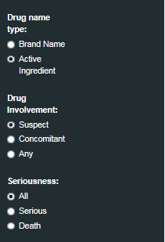

Figure 11. Drug search options

The drug name type has been changed to “Active Ingredient” because the drug ibuprofen is considered an active ingredient. In addition, the drug involvement has been left at “Suspect” because we are only interested in adverse reactions directly related to ibuprofen, and seriousness has been left as “All” because we are looking for all adverse reactions (figure 11).

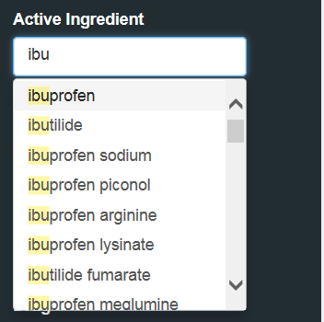After at least filling in the drug name type, the user can now search the drug name of interest (figure 12).

Figure 12. Drug search bar

After only a few letters have been typed the desired active ingredient pops up and can be selected (figure 12).

Scrolling vertically down the search options, the user has the choice to filter patient information and/or adverse reactions (figure 13).

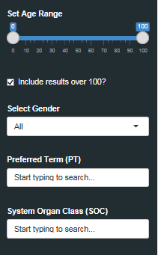

Figure 13. Adverse reaction and patient information search options

This example is interested in all adverse reactions and reports directly linked to ibuprofen and as a result this section will be left at default in order to display all relevant results (figure 13).

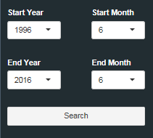The last section of the search tools walkthrough is simply choosing the desired time frame of report and clicking search (figure 14).

Figure 14. Report date options

This example is interested in reports from the past 20 years; the end year has been left at the default (the last time the CV App was updated) and the start year, 20 years before that date (figure 14).

## 5.2 Results display

The next step would be to choose the relevant option from the results tabs (figure 15).

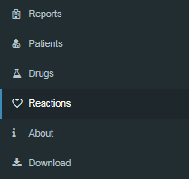

Figure 15. Results display

In order to view the results that displays the adverse reactions the user must select the “Reactions” tab (figure 15).

The last step in this example would be to view the results under the “Most Frequent Adverse Events” graph and observe the results (figure 16).

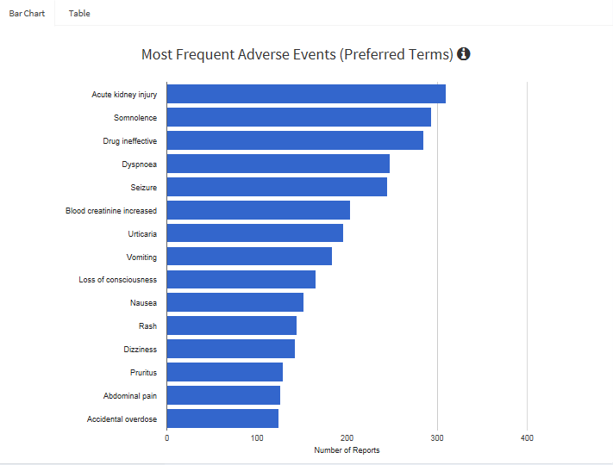

Figure 16. Most frequent adverse events (PT) graph

Although given the option to view the most frequent adverse events in preferred terms or high-level terms, for the purpose of this example only the preferred term is shown due to its higher specificity in labelling adverse events. As well, the graph shows the most commonly reported adverse reactions for ibuprofen in the Canada Vigilance Adverse Reaction Database according to the example’s specifications (figure 16). It is important to note that the results display do not imply that ibuprofen has caused any of these adverse reactions, but rather displays possible trends present in the reports.

1. https://www.canada.ca/en/health-canada/services/drugs-health-products/medeffect-canada/adverse-reaction-database/medeffect-canada-caveat-privacy-statement-interpretation-data-search-canada-vigilance-adverse-reaction-online-database.html
2. https://www.canada.ca/en/health-canada/services/drugs-health-products/medeffect-canada/adverse-reaction-database/glossary.html
3. https://www.canada.ca/en/health-canada/services/drugs-health-products/medeffect-canada/adverse-reaction-database/glossary.html
4. https://www.meddra.org/how-to-use/basics/hierarchy
5. https://www.meddra.org/how-to-use/basics/hierarchy
6. https://www.canada.ca/en/health-canada/services/drugs-health-products/medeffect-canada/adverse-reaction-database/glossary.html
7. https://www.meddra.org/how-to-use/basics/hierarchy
8. https://www.canada.ca/en/health-canada/services/drugs-health-products/medeffect-canada/adverse-reaction-database/glossary.html#s